**Page 1 – welcome messages and introduction**

**Can you help us analyse MRI brain scans and help cure brain diseases?**

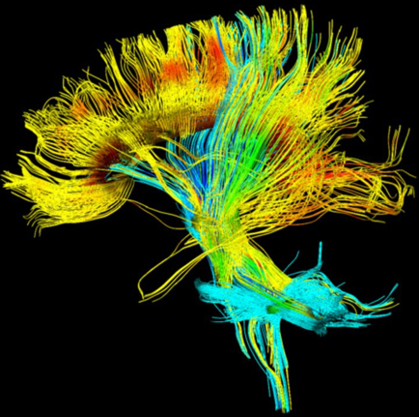

**Siemens rotating tracts in a loop**

At Cardiff University Brain Research Imaging Centre (CUBRIC) we map out the pathways in the brain using state-of-the-art diffusion Magnetic Resonance Imaging (dMRI).

Its important we map these pathways correctly.

We need your help to tell us which pathways are wrong!

Anyone can take part and no scientific background is needed. Join us and together we can learn more about the brain and help scientists pioneer cures for diseases such as dementia and schizophrenia.

**Reward image outline appears –** This brain tract will progress as you work your way through the app. After you complete a section you will be rewarded with the next portion of the tract and an interesting fact about the brain!

**Page 2 – about brain imaging**

**What is diffusion MRI?**

Diffusion MRI is currently the only brain imaging technique that allows us to look at white matter in living people. It produces images like this:

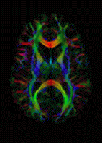

**Why do we want to look at the white matter in the brain?**

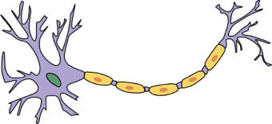White matter is often referred to as ‘the wiring of the brain’ and is made up of structures called axons.

Axons are important nerve fibres which carry information about our environment, our vital organs and even our memories. Bundles of axons join together to form pathways called fibre tracts which can transport this information to different parts of the brain.

In certain brain diseases such as dementia and schizophrenia, some of these white matter pathways are thought to become disrupted. Using diffusion MRI, researchers can identify these abnormal pathways and strive to develop better treatments that can target these areas in the brain.

**How does diffusion MRI work?**

Diffusion MRI uses the random motion of water molecules to create a picture of the brain.

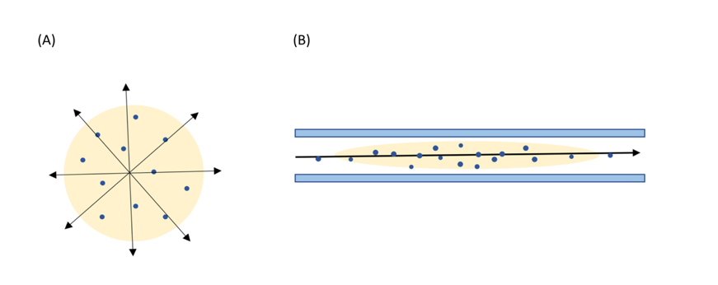In the grey matter, water molecules are free to move equally in all directions:

However, axons in the white matter are covered in a waterproof coat called the myelin sheath. This means that water can only move in one direction - along the length of the axon

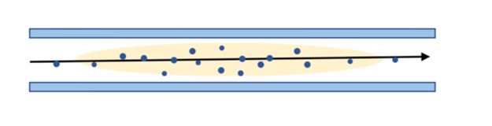

Diffusion MRI works by tracing the motion of water molecules along axons. Using this technique, scientists can generate a 3D map of the brain charting the direction of white matter fibre tracts. An example is shown below:



**We want you to help us model the fornix – but what is the fornix and why are we interested in it?**

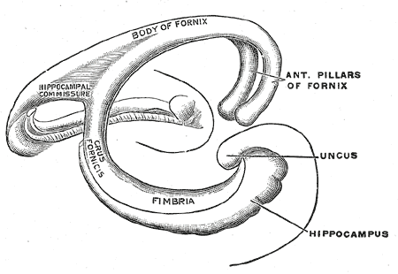The fornix is a white matter bundle in the temporal lobe of the brain. It is shaped a bit like a wishbone in a chicken, with two ‘legs’ going into each hemisphere of the brain. It is a critical structure thought to be involved in memory formation, learning ability and advanced cognitive activities.

Due to its role in memory systems, the fornix has become a focus of research in dementia. Diffusion MRI scans can reveal disease-related changes in the structure of the fornix before patients get any symptoms. This may help scientists identify individuals at high risk of developing Alzheimer’s.

**How do we model the fornix?**

Using information from diffusion MRI we can reconstruct 3D fibre tracts in living brains. We do this using a software called probabilistic tractography. Here are some of the results of tractography:

**What is a good image and what is a bad image of the fornix:**

**Reward image: The frontal lobe**

Well done - you just unlocked the frontal lobe! The frontal lobe is involved in thinking, decision making and planning. It is also thought to play a key role in determining our personality.

**Involuntary contributors to neuroscience:**

In 1848 Phineas Gage, a railroad worker, was using an iron rod to pack explosives. In an accident that detonated these explosives, the iron rod was driven through Gage’s frontal lobe. Miraculously, he survived the incident, however friends reported that he was ‘no longer Gage.’ He was said to have lost all sense of social inhibition, swearing publicly and frequently making inappropriate remarks.

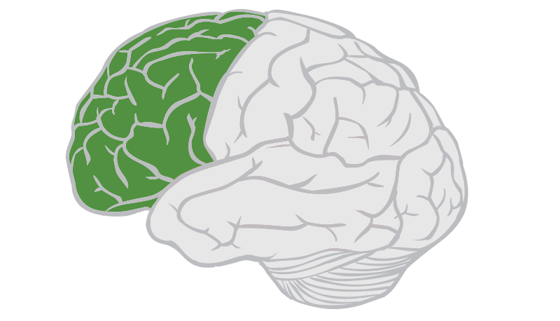[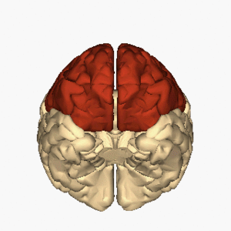](https://en.m.wikipedia.org/wiki/Frontal_lobe_disorder#/media/File%3ACerebrum_-_frontal_lobe_-_inferior_view_animation.gif)

**Page 3 – some training**

The fornix should have a central ‘body’ and two ‘legs’ that curl around underneath.

**What a good fornix looks like**

This is what a good fornix tractography image looks like from the top:

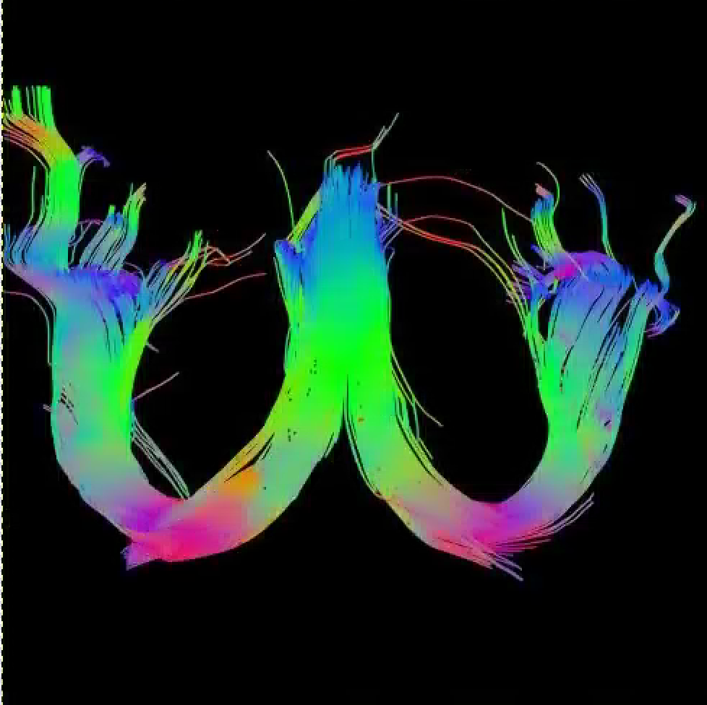

from the front:

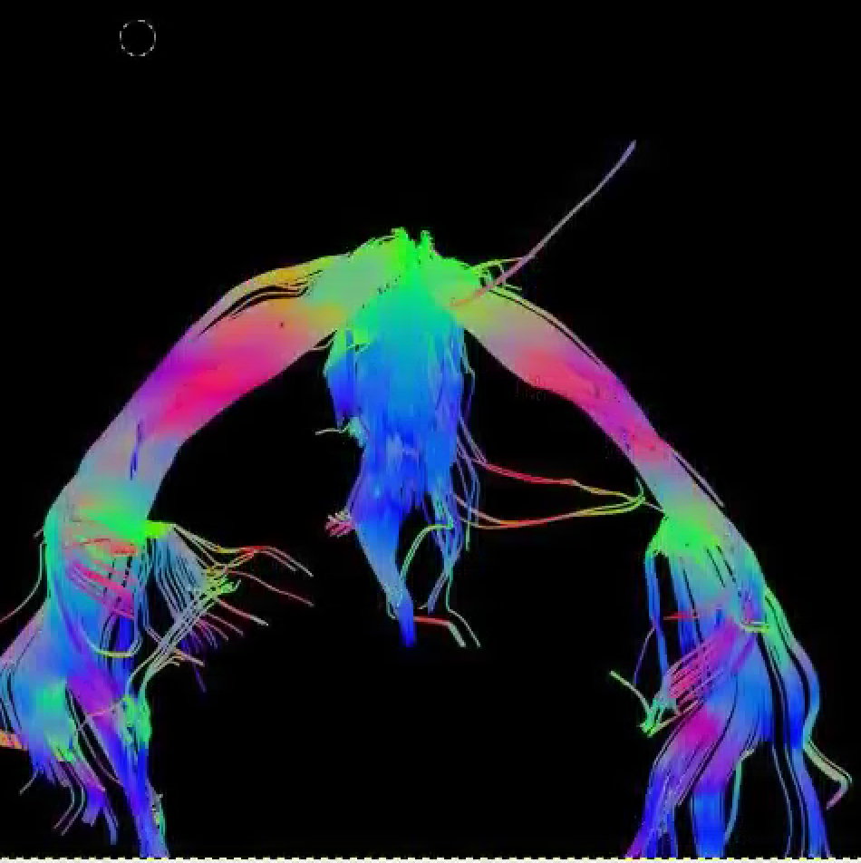

and from the side:

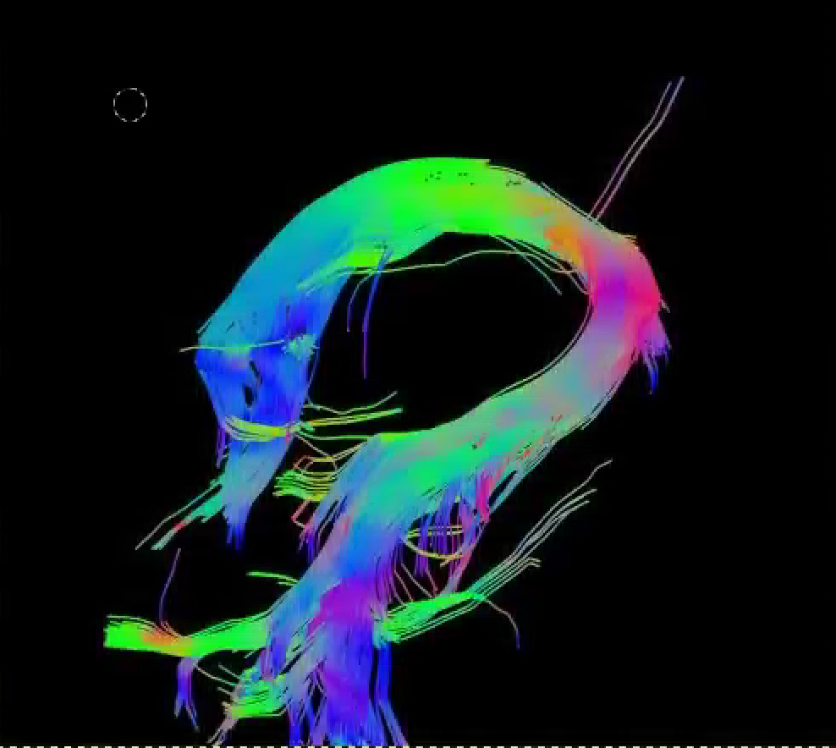

**Not perfect-looking, but OK**

It shouldn’t have too many untidy-looking fibres that stick out across the middle or out of the sides (although a few are OK):

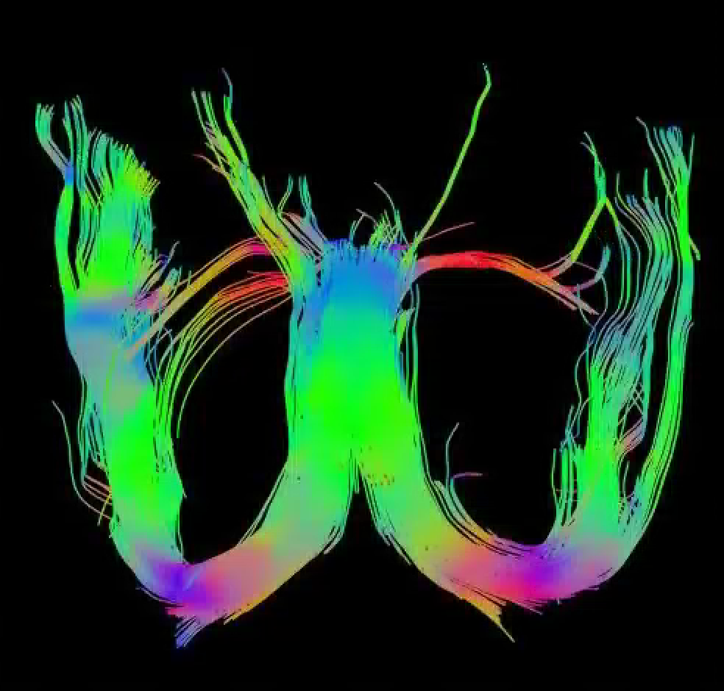

Sometimes the tract images are not symmetrical and have only a few fibres on one side. Not everyone’s brains are the same on both sides:

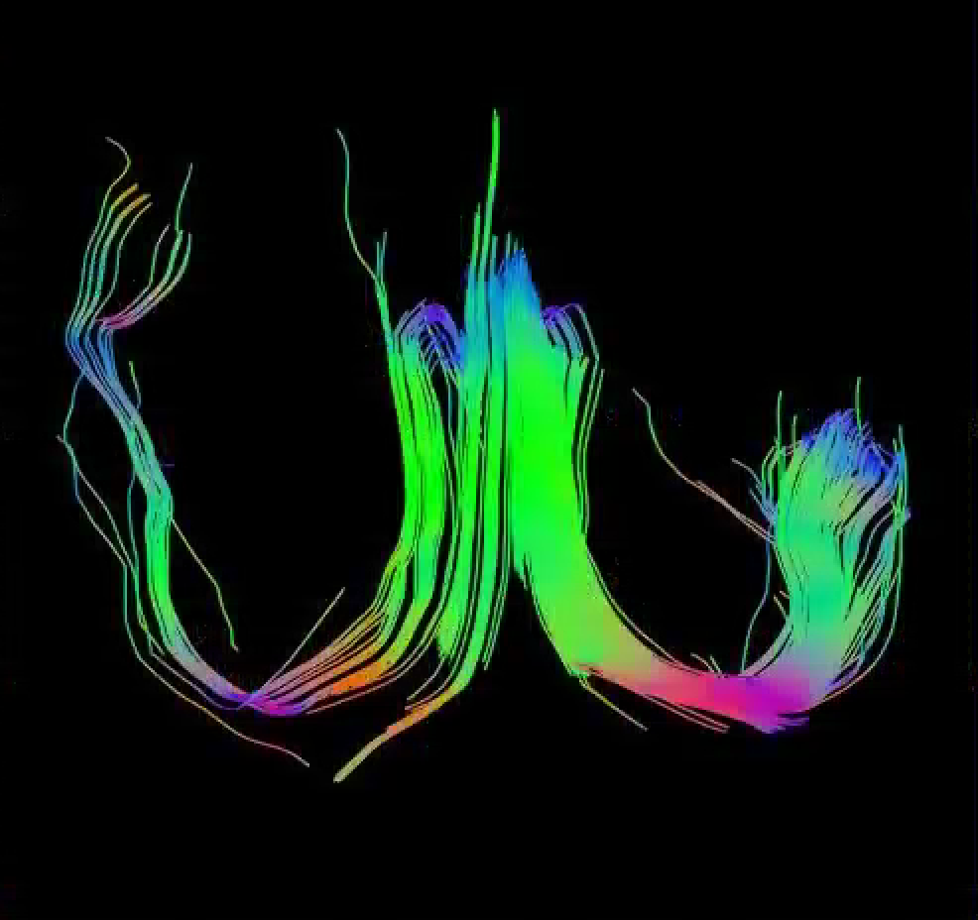

It’s okay if there is a gap down the middle of the body:

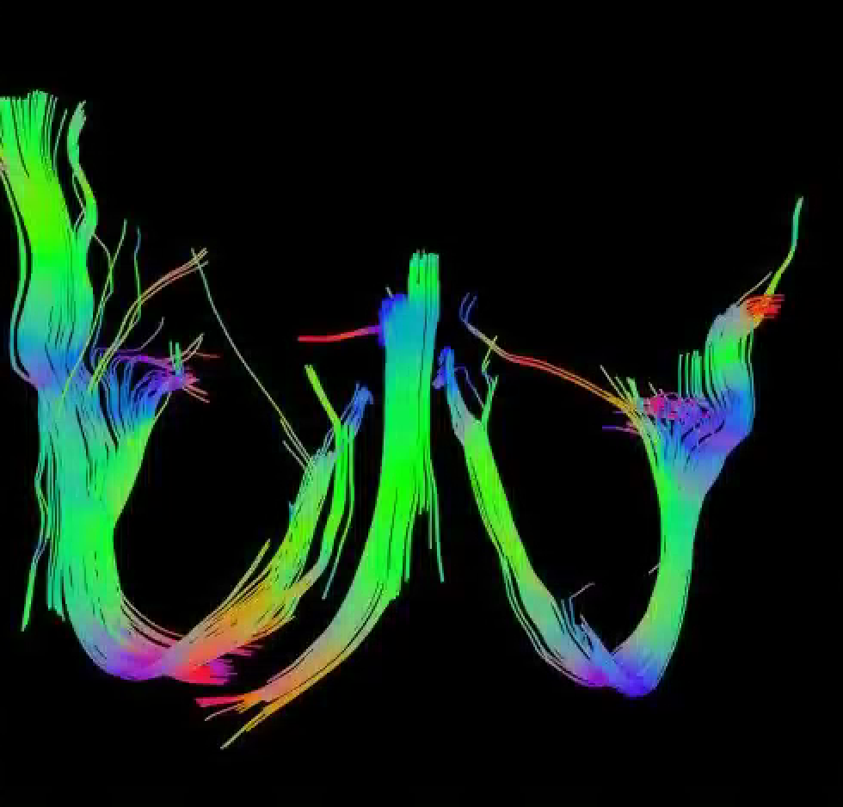

**Bad ones!**

If one leg has only 2-3 fibres, it is a mistake:

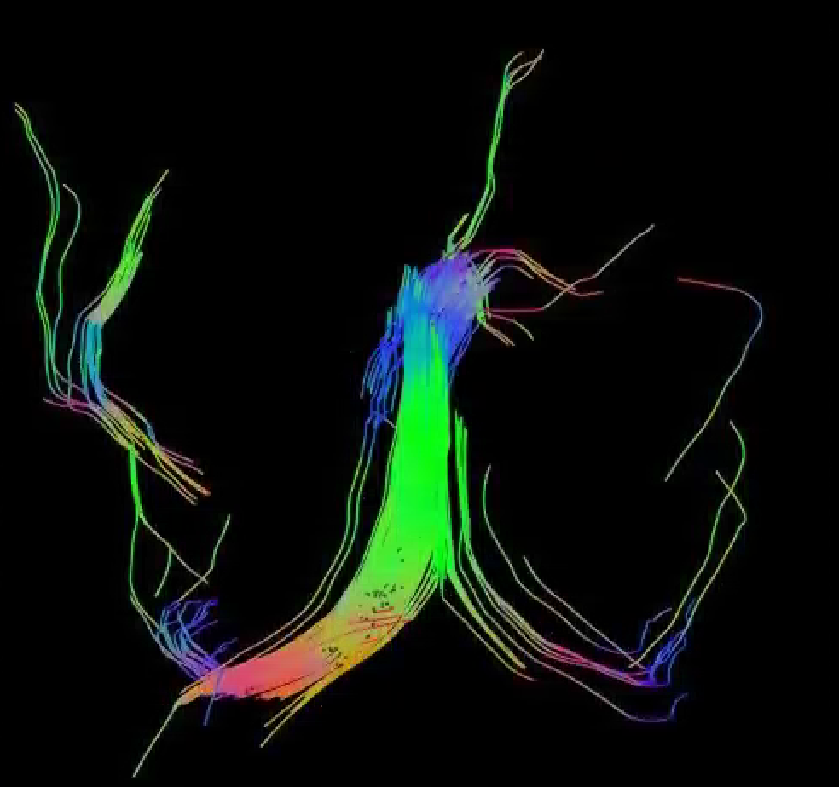

There shouldn’t be any gaps between the body and the legs. If the legs look like they have been cut off, it is a mistake:

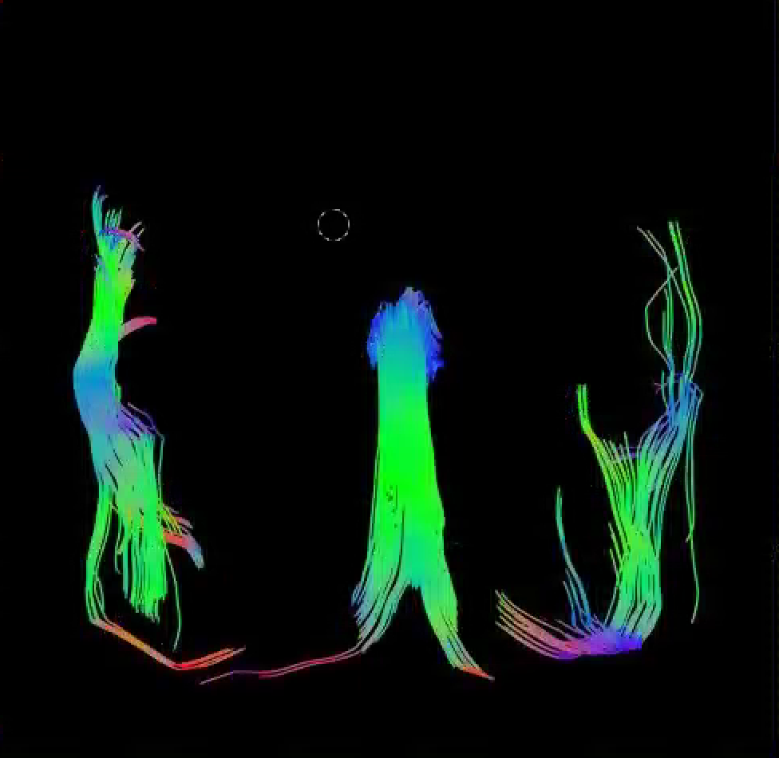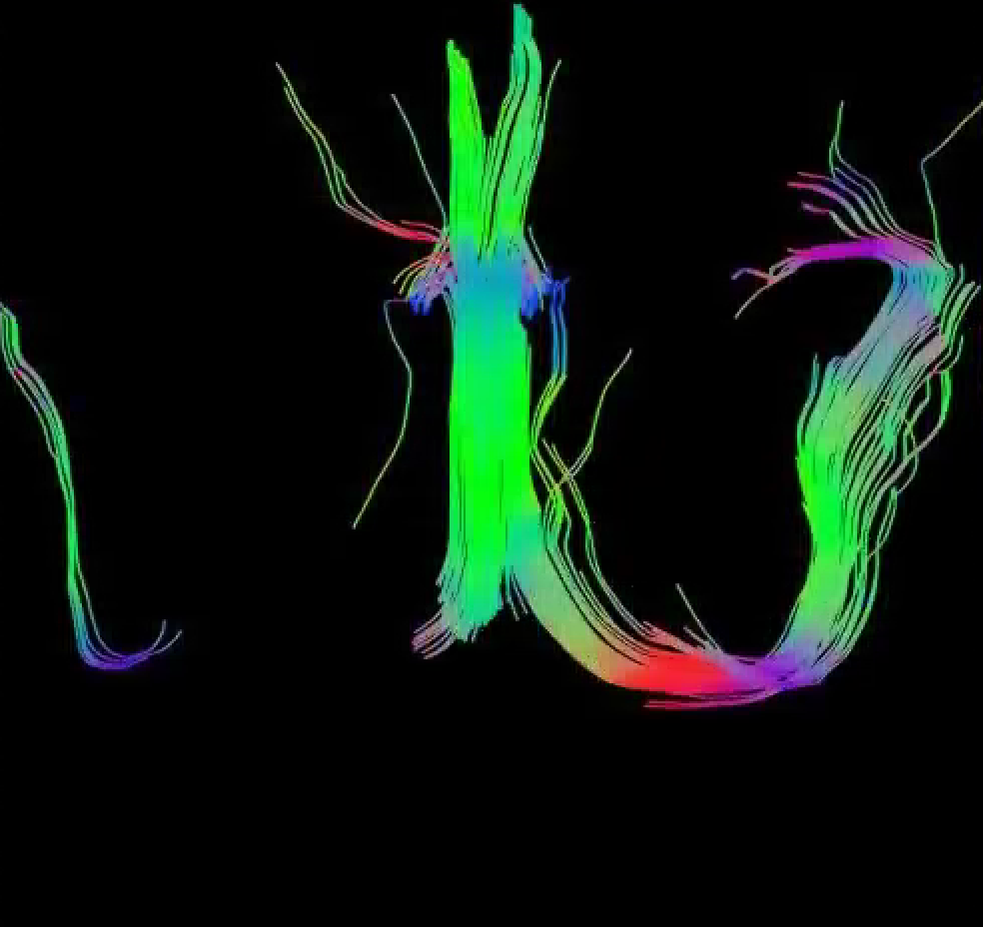

**Have a go at looking at some images for us:**

Training phase – 10 images. Please ten of the following in a random order:

4404

4537

6979

2352

823

1072

2047

1495

2411

988

10014

10046

10235

10255

10376

10316

1795

2338

10297

10303

**Page 4 – How did you do?**

‘Great’ ‘Fantastic ‘Well done’

‘You are ready to help us sort some real imaging data!’

‘You spotted X/X problem fornix images’

**Button that allows people to retake the test again with different images**

**Reward image: The occipital lobe**

Fantastic work! - you just unlocked the occipital lobe.

**The eyes in the back of your head:**

The occipital lobe sits at the back of the brain. It processes the information we see and allows us to remember and assign meanings to different images.

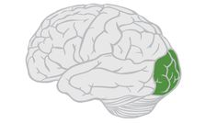

**Page 5 – registration**

Please register to help us sort some real research images

**Page 6 – Have a go for real**

‘Swipe the left button to discard the images you think are incorrect’

‘Swipe the right button to keep the scans you think are correct’

**At 25 images –** ‘well done! You are halfway through!’ **Reward image – temporal lobe**

**The temporal lobe:**

Great work! You just unlocked the temporal lobe. The temporal is involved in perceiving and remembering sounds. It also works in conjunction with the hippocampus to form conscious memories.

**The case of Henry Molaison 1926-2008:**

From an early age, Henry suffered from severe epilepsy. In an effort to control his seizures, he had an operation that removed a large part of his temporal lobe and hippocampus on both sides. Whilst the surgery cured him of his epilepsy, tragically he was left unable to form new memories.

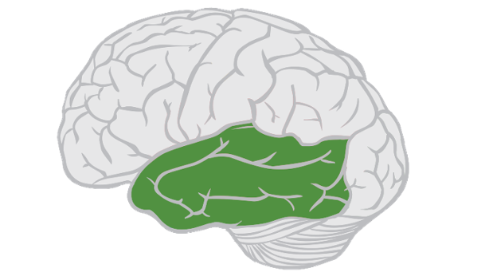

**At 50 images –** ‘Finished your first 50!’ **reward image – parietal lobe**

**The parietal lobe:**

Well done – you just unlocked the parietal lobe! The parietal lobe contains an area of gray matter called the sensory strip. This processes sensory information such as pain, touch and temperature.

**The somatosensory homunculus:**

The sensory strip contains a map of our body. This is called the somatosensory homunculus and is shown below. When you touch something soft with your hand, this information will travel up to the sensory strip to where the hand is mapped on the homunculus.

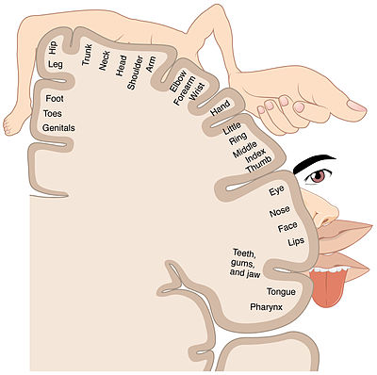

Neurosurgeons use the homunculus as anatomical guidance during surgery. For example, if they touch the wrist mapped on the sensory strip, the patient may feel as if someone is actually touching their wrist!

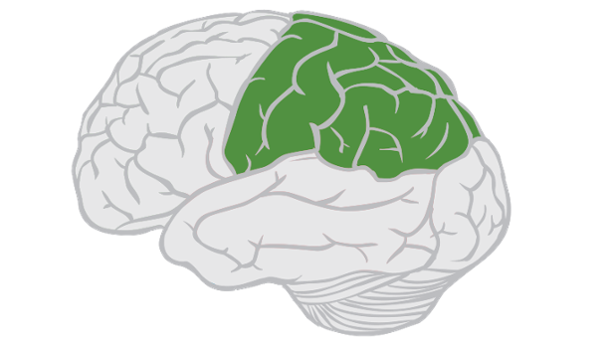

Offer option to ‘Do another 10!’ Up to 10 times or ‘Give us feedback and get your certificate’

**Page 7 – tell us what you think**

Feedback

**Reward image - The cerebellum:**

Excellent! You have unlocked the cerebellum. The cerebellum is Latin for ‘little brain.’ This area is vital for fine tuning your movements and controlling balance.

**The cerebellum in disease:**

Diseases such as multiple sclerosis and brain tumours can cause damage to the cerebellum. Patients with this condition often walk with an unstable, uncoordinated gait and frequently stumble or fall over.

